BSDCan 2004
The BSD event of 2004
http://www.bsdcan.org/
Ottawa, Canada
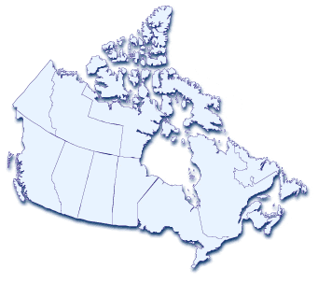

BSDCan 2004– The event to be at this year

BSDCan 2004
There’s only one major BSD Event in North America this year: BSDCan 2004.

Where
Ottawa, Canada

When
May 13-16, 2004

Who
Developers, contributors, and users

Venue
University of Ottawa
http://www.uottawa.ca/

At Fees You Can Afford
We plan to keep costs to a minimum. As such, the conference will be held at University of Ottawa and accommodation is available within the University residences. Hotels are also within close walking distance of the conference venue.
Costs have not been determined, but initial estimates indicate that the attendance fee will be less than CAD$200 (approximately US$150). An announcement will be sent out on our mailing list when the fee has been determined.

Schedule overview
Thursday 13 May 2004
2:00 pm Sign-in desk opens. Pick up your badge early
6:00 pm Sign-in desk closes
Friday 14 May 2004
10:00 am First set of talks
11:00 am break
11:30 am Second set of talks
12:30 pm Break for lunch
2:00 pm Third set of talks
3:00 pm break
3:30 pm Fourth set of talks
5:30 pm Proceedings end for the day
Saturday 15 May 2004
10:00 am First set of talks
11:00 am break
11:30 am Second set of talks
12:30 pm Break for lunch
2:00 pm Third set of talks
3:00 pm break
3:30 pm Key signing party
5:30 pm Proceedings end for the day
Sunday 16 May 2004
Social activities, yet to be announced

Talks
These are only a few of the talks arranged. Please see the website for full details.
- Network Buffer Allocation in the FreeBSD Operating System
- Extreme Programming in a Geographically Dispersed Project
- Using Bacula over untrusted networks
- The NetBSD cross platform build environment
- iBooks for geeks
- Introduction to pf
- Introduction to Ports
- Encrypted filesystems + comparison
- Introduction to pseudo and stackable file systems under BSD
- Exploit Mitigation Techniques
- OpenBSD firewalls
- Homebrew embedded systems with BSD.
- Using Perl to write command line utilities

Call for papers
This is the schedule for formal papers. If you want to give a talk, let contact us at papers@bsdcan.org.
19 September 2003 Proposals acceptance begins
19 November 2003: Proposals acceptance ends
19 December 2003: Confirmation of accepted proposals
19 January 2004: Abstracts due
19 March 2004: Formatted final papers deadline

Social activities
It’s not all work. Social activities play a major factor in project development.
Thursday 13 May 2004
4:00 pm Drinks at local pub
Friday 14 May 2004
5:00 pm BOFs
7:00 pm Gathering at local eateries for dinner
Saturday 15 May 2004
8:00 pm Gathering at local pubs for drinks

BOFs
- Future directions for the BSD file system
- libpcap 1.0
- DragonFly BSD
- FreeBSD
- OpenBSD
- NetBSD
- IPSec

http://www.bsdcan.org/


BSD Daemon Copyright 1988 by Marshall Kirk McKusick. All Rights Reserved.

BSDCan
http://www.bsdcan.org/

