
The Bacula® Storage Management System
It comes by night and sucks the vital essence from your computers
http://www.bacula.org/

What is bacula?

Bacula is a set of computer programs that permit you (or the system administrator) to manage backup, recovery, and verification of computer data across a network of computers of different kinds. In technical terms, it is a network Client/Server based backup program. Bacula is relatively easy to use and efficient, while offering many advanced storage management features that make it easy to find and recover lost or damaged files. Due to its modular design, Bacula is scalable from small single computer systems to systems consisting of hundreds of computers located over a large network.

Who needs bacula?
If you are currently using a program such as tar, dump, or bru to backup your computer data, and you would like a network solution, more flexibility, or catalog services, Bacula will most likely provide the additional features you want.
If you are running Amanda and would like a backup program that can write to multiple volumes (i.e. is not limited by your tape drive capacity), Bacula can most likely fill your needs. A number of our users report that Bacula is simpler to setup and use than other equivalent programs.
If you are currently using a sophisticated commercial package such as Legato Networker. ARCserveIT, Arkeia, or PerfectBackup+, you may be interested in Bacula, which provides many of the same features, and is free software available under the GNU Version 2 software license.

Interactions between the Bacula SErvices
The following block diagram shows the typical interactions between the Bacula Services for a backup job. Each block represents in general a separate process (normally a daemon). In general, the Director oversees the flow of information. It also maintains the Catalog.
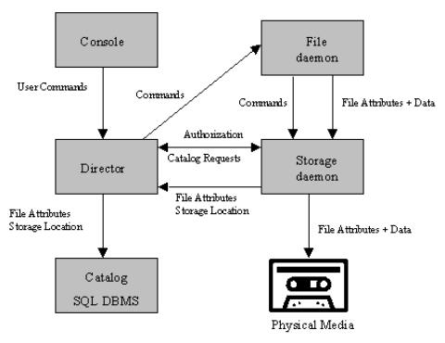

The current state of bacula
- Network backup/restore with centralized Director.
- Internal scheduler for automatic Job execution.
- Scheduling of multiple Jobs at the same time.
- You may run one Job at a time or multiple simultaneous Jobs.
- Job sequencing using priorities.
- Restore of one or more files selected interactively either for the current backup or a backup prior to a specified time and date.
- Restore of a complete system starting from bare metal. This is automated for Linux systems and partially automated for Solaris.
- Ability to recreate the catalog database by scanning backup Volumes.
- Console interface to the Director allowing complete control. Curses, GNOME/GTK and wxWindows versions of the Console program are available.
- Verification of files previously cataloged, permitting a Tripwire like capability (system break-in detection).
- CRAM-MD5 password authentication between each component (daemon).
- Catalog database facility for remembering Volumes, Pools, Jobs, and Files backed up.
- Support for SQLite, PostgreSQL, and MySQL Catalog databases.
- Labeled Volumes, preventing accidental overwriting (at least by Bacula).
- Any number of Jobs and Clients can be backed up to a single Volume.
- Multi-volume saves. When a Volume is full, Bacula automatically requests the next Volume and continues the backup.
- Machine independent Volume data format. Linux, Solaris, and Windows clients can all be backed up to the same Volume if desired.
- Multi-threaded implementation.
- Mechanisms to handle arbitrarily long filenames and messages.
- GZIP compression on a file by file basis done by the Client program if requested before network transit.
- Cross-network communication between components can be protected with TLS
- Computation of MD5 or SHA1 signatures of the file data if requested.
- Autochanger support using a simple shell interface that can interface to virtually any autoloader program.
- Listing and Restoration of files using stand-alone tools.
- A flexible message handler including routing of messages from any daemon back to the Director and automatic email reporting.
- Support for autochanger barcodes -- automatic tape labeling from barcodes.
- User extensible queries to the SQLite, PostgreSQL and MySQL databases.
- All Volume blocks (approx 64K bytes) contain a data checksum.
- Pool and Volume library management providing Volume flexibility (e.g. monthly, weekly, daily Volume sets, Volume sets segregated by Client, ...).

Advantages of Bacula over other solutions
- Since there is a client for each machine, all attributes of files are properly saved and restored.
- Clients may be backed up and restored using NFS or Samba.
- Bacula handles multi-volume backups.
- Comprehensive manual
- A full comprehensive database of all files backed up permitting online viewing of files saved on any particular Volume.
- Automatic removal of old database records simplifies database administration.
- Any SQL database engine can be used making Bacula very flexible.
- The modular but integrated design makes Bacula very scalable.
- Any user database or other application can be properly shutdown by Bacula using the native tools of the system, backed up, then restarted (all within a Bacula Job).
- Bacula has a built-in Job scheduler.
- The Volume format is documented and there are simple C programs to read/write it.
- Bacula uses well defined (registered) TCP/IP ports -- no rpcs, no shared memory.
- Bacula installation and configuration is relatively simple compared to other comparable products.
Bacula – your open source network backup solution
http://www.bacula.org/

2005.02.16

